IE2 Search Guide



Contents
Search Pages Introduction……………………………………………..3
Your Search Criteria .……………………………………………………..4
Your Search Results …………………………………………………..….5
Download Options…………………………………………………………6
Saved Searches………………………………………………………………7
Publishing Saved Searches……………………………………………..7

Search Pages Introduction
The Search Engine is accessible in each application by clicking the Search button from the 2nd menu bar.
There are 2 sub tabs within the Search Engine – Spotlight and All Tables.
The Spotlight tab breaks up the database into smaller ‘spotlight’ groups of tables as shown in the first image below.
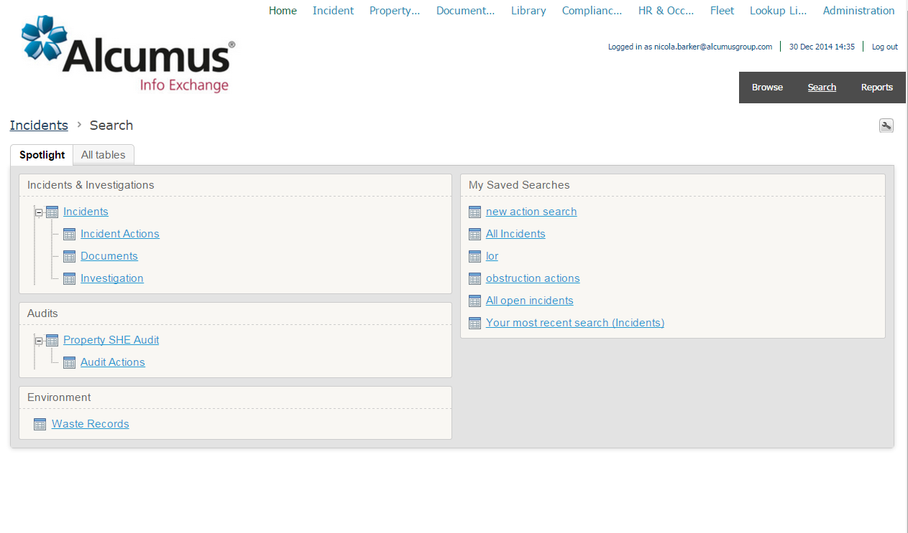
The All tables tab displays the full hierarchy of tables that are available to the user in the current application. This could be displayed as a very long page of tables for applications with a large number of data tables.
Saved Searches will usually be displayed on the right hand side of the Spotlight search page providing easy access to re-run searches that have previously been set up and saved.

Your Search Criteria
Select a table to begin a new search.
Your Criteria (as shown below) will provide some fields as default options to define your required search criteria.
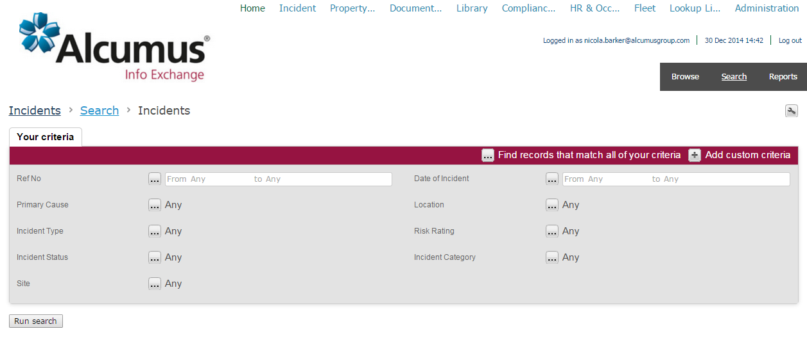
Make as many selections as required – the default setting is to find records that match all of your criteria. It is possible to change this to find records that match any of your criteria by using the ‘Find records that match…’ selector from the top of the Criteria box.
To add additional fields to the criteria area use the ‘Add custom criteria’ option. Tick as many additional fields as are required.
Fields that are from a related table can also be used as search criteria by selecting the link at the bottom of the additional criteria pop-up below and navigating to the required table then ticking the field.
When all required criteria has been entered, click on the Run Search button.
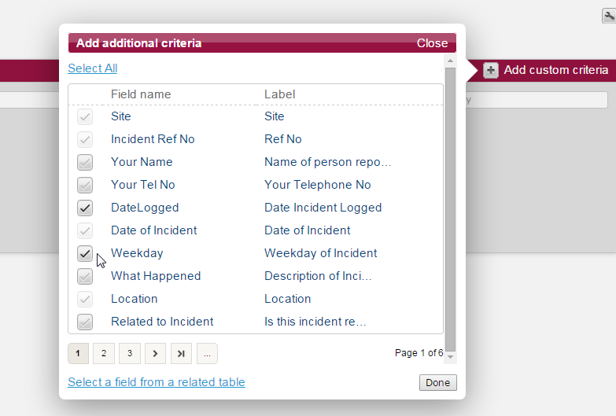

Your Search Results
Your results will appear at the bottom of the page below Your criteria.
The number of results found that match your criteria will be displayed in brackets.
It is possible to refine your criteria further and then click ‘Re-run search’ to alter the results that are returned.
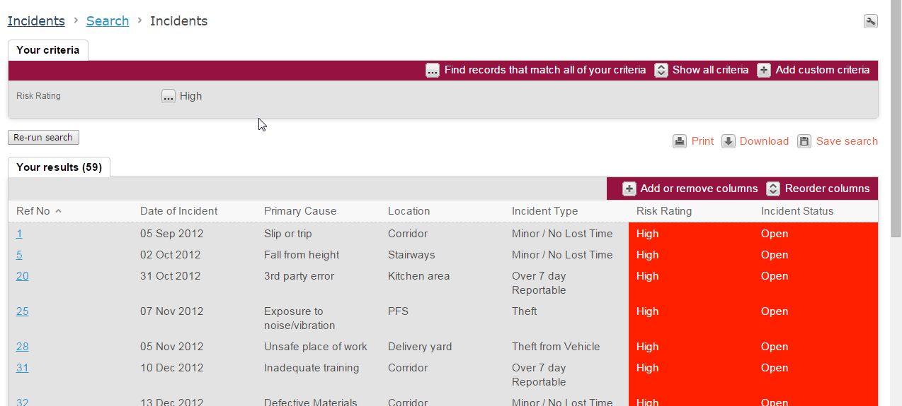
A few key fields will be included as columns in your results by default.
Use the ‘Add or Remove Column’s button to add additional fields into your results in the same way as adding criteria. This includes navigating to related tables.
Use the ‘Reorder Columns’ button to change the order of the fields included in your results.
It is possible to view a record in more detail by clicking into one of the rows from your results – an option to return to search results will be available from both the edit and summary pages.
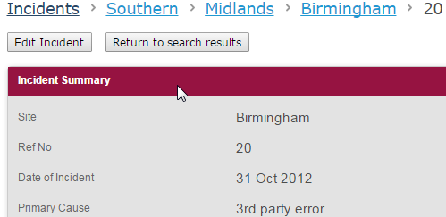

Download options
All searches will include the option to Print – select the ‘Print’ button from between your criteria and your results and then use the printer options to set up the page layout and other formatting options.
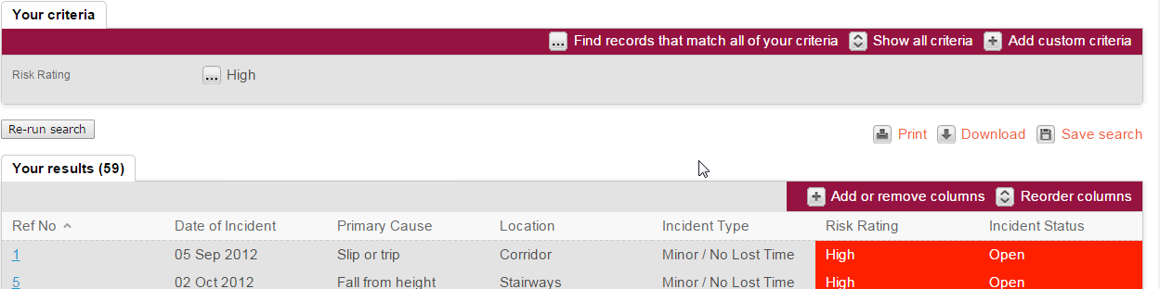

The Download button will provide a choice of either PDF or CSV.
Selecting PDF will allow for further Page Size and Orientation settings to be chosen.
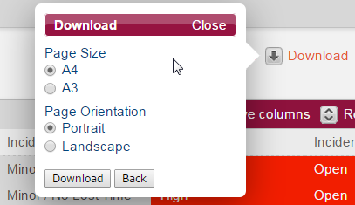

Saved Searches
All users have the ability to save searches that will be available to re-run under the users own account.
To save a search, complete the criteria selection and update results with any additional columns and reordering that is required and then select the ‘Save search’ button from between the criteria and results area.
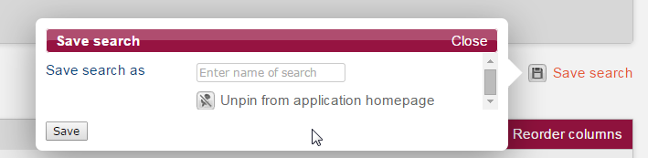
Enter a name for the search and then click the Save button.
The search will now be saved on the Spotlight search page to be re-run as required.
The saved search will also be pinned to the application homepage by default – use the unpin option shown above to remove a saved search from the homepage quick links.
Publishing Saved Searches
Nominated users can also have additional privileges to publish saved searches for all users to run.
An additional tick box will be available under the Save search option providing the ability to ‘publish’ the search to the Spotlight page of saved Searches for all users of the current application.
Permissions to be able to publish saved searches can be granted by contacting the Info Exchange Helpdesk on 01926 844211 or emailing helpdesk@alcumusgroup.com

